**Data Transformation**

We are going to perform Data Transformations using the Azure DataBricks.

🡪Creating an Azure DataBricks Workspace

Search for Azure Databricks in the Azure search bar and click on it.

Then click on create

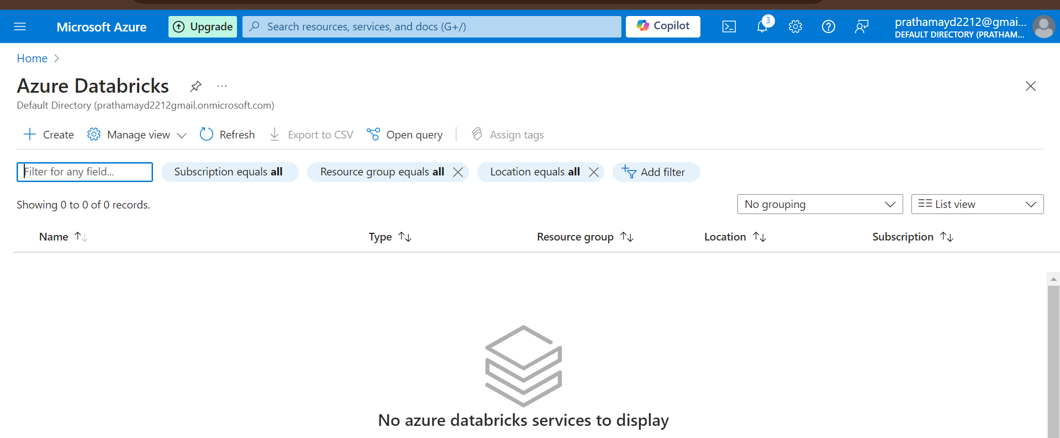

Enter the details as shown below and create the workspace and it will deploy the changes.

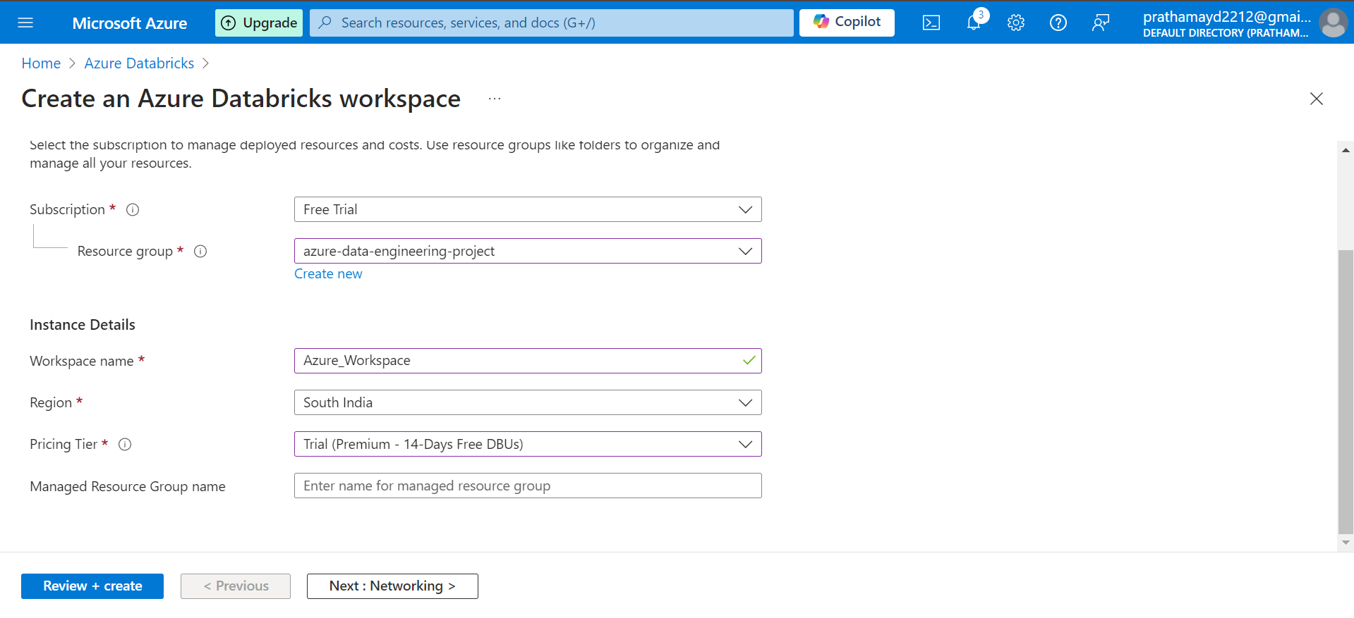

Once created, you will get an option to go to the resource and then launch the workspace, and you will have your azure databricks workspace ready to use.

Create a compute to work on the workspace in Azure Databricks.

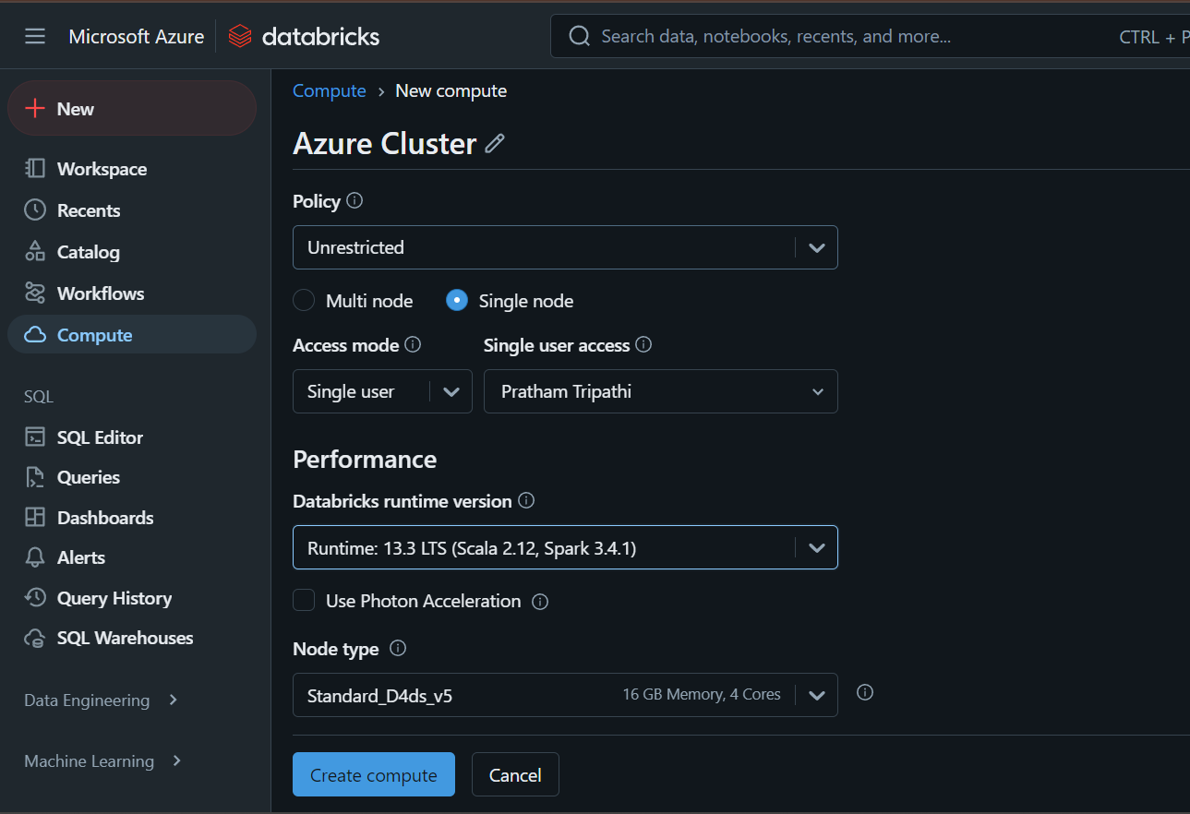

Configure the compute as shown in the screenshots.

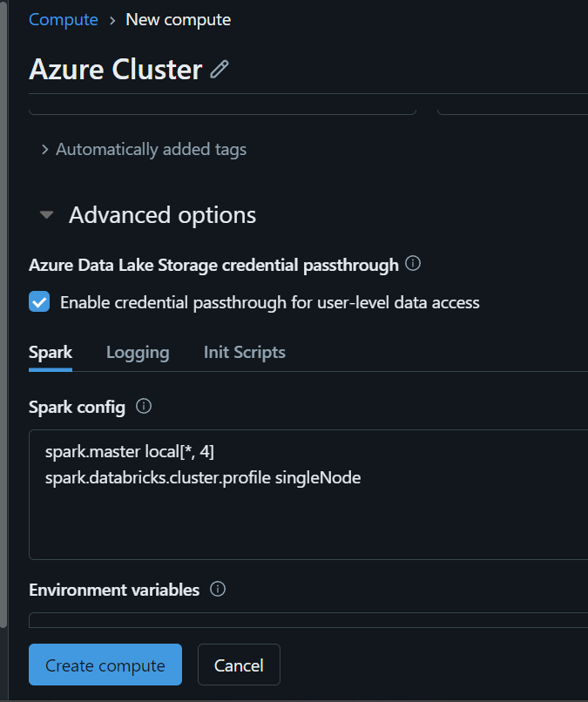

**CREATE**

**🡪Create a notebook and use the below code to mount the containers to databricks**

**configs = {**

**"fs.azure.account.auth.type": "CustomAccessToken",**

**"fs.azure.account.custom.token.provider.class": spark.conf.get("spark.databricks.passthrough.adls.gen2.tokenProviderClassName")**

**}**

**# Optionally, you can add <directory-name> to the source URI of your mount point.**

**dbutils.fs.mount(**

**source = "abfss://bronze@pratdatalakegen2.dfs.core.windows.net/", #Add your container name and storage ac name**

**mount_point = "/mnt/bronze",**

**extra_configs = configs)**

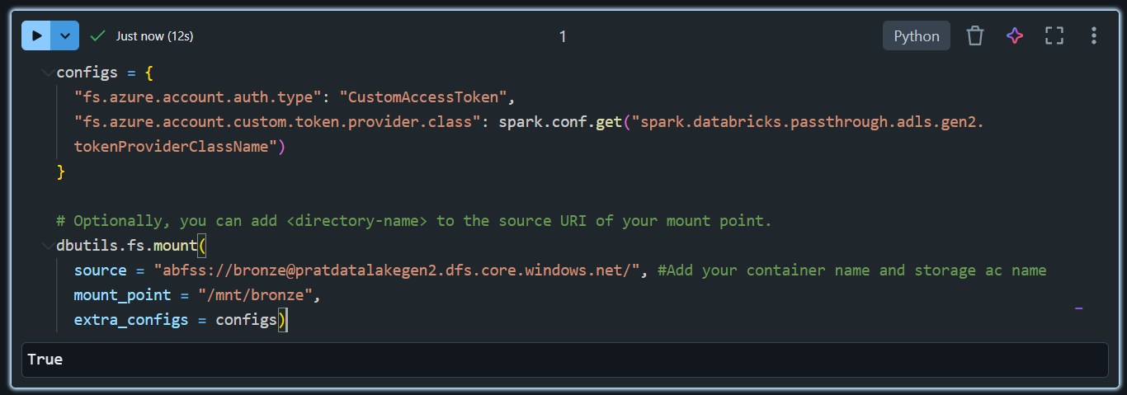

**If you get any error regarding permissions.**

**Go to your storage account 🡪 IAM Roles and add the below permissions in thr assign roles**

* Storage Blob Data Contributor
* Reader
* Reader and Data Access

🡪Check the data using dbutils

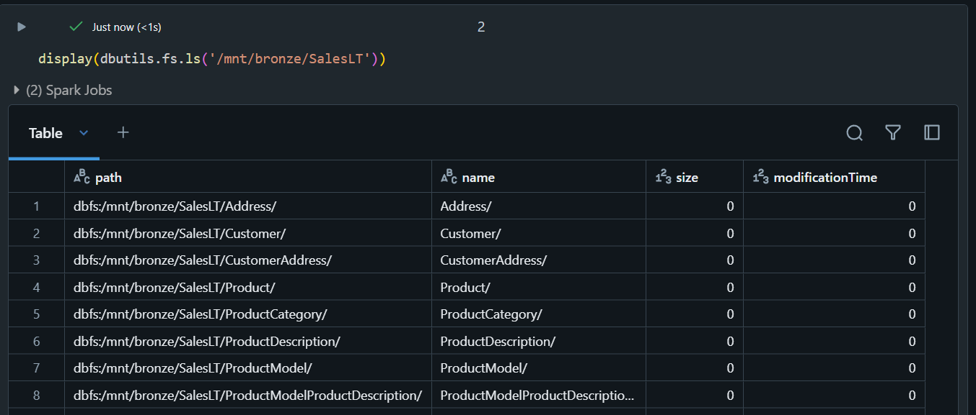

Then mount the silver and Gold container as well:

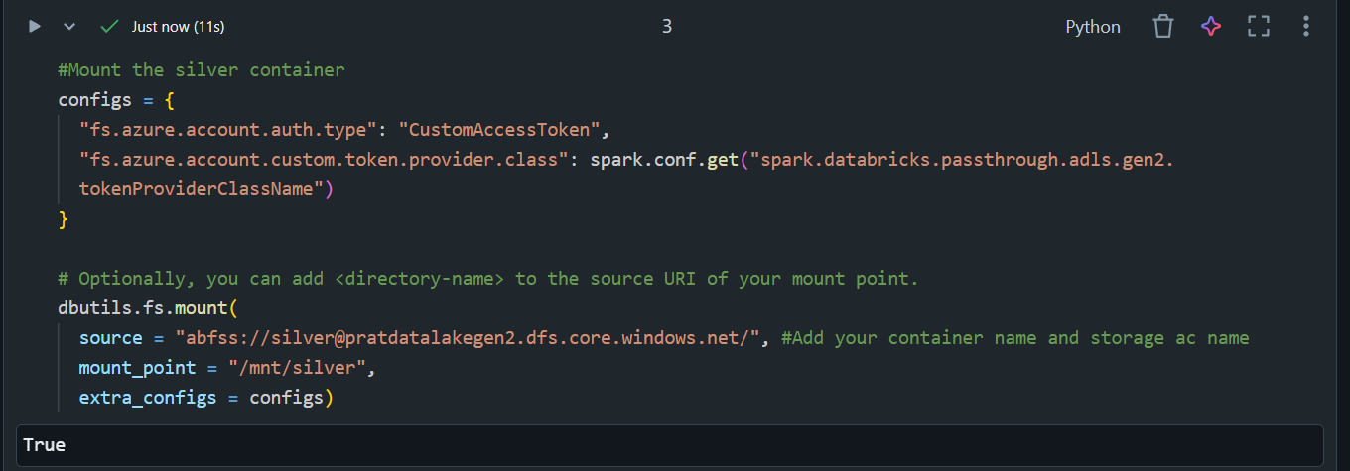

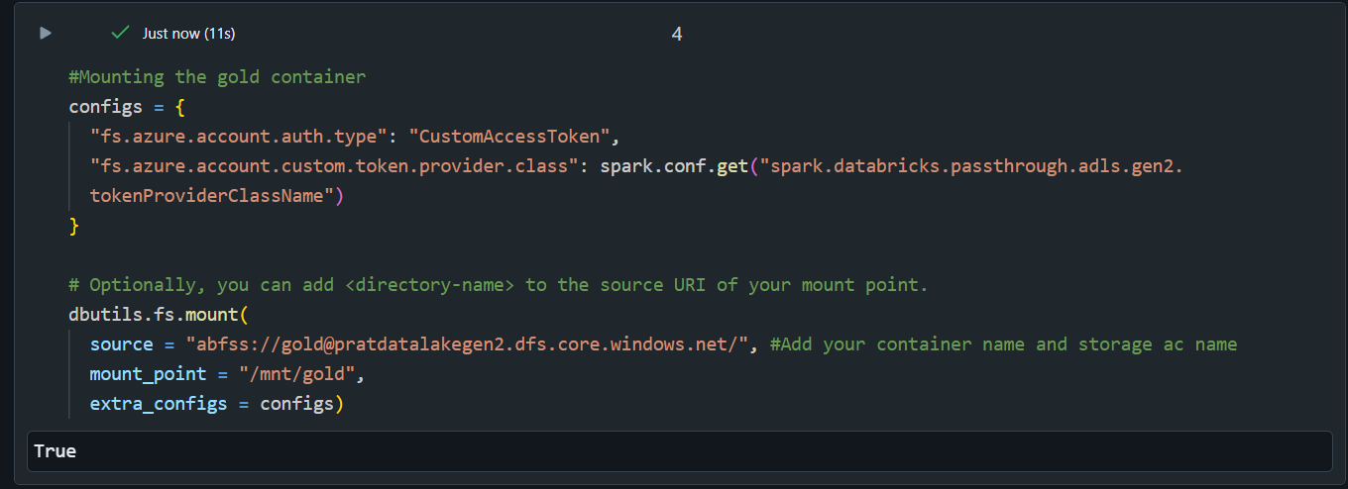

**Silver:**

#Mount the silver container

configs = {

  "fs.azure.account.auth.type": "CustomAccessToken",

  "fs.azure.account.custom.token.provider.class": spark.conf.get("spark.databricks.passthrough.adls.gen2.tokenProviderClassName")

}

# Optionally, you can add <directory-name> to the source URI of your mount point.

dbutils.fs.mount(

  source = "abfss://silver@pratdatalakegen2.dfs.core.windows.net/", #Add your container name and storage ac name

  mount_point = "/mnt/silver",

  extra_configs = configs)

**Gold:**

#Mounting the gold container

configs = {

  "fs.azure.account.auth.type": "CustomAccessToken",

  "fs.azure.account.custom.token.provider.class": spark.conf.get("spark.databricks.passthrough.adls.gen2.tokenProviderClassName")

}

# Optionally, you can add <directory-name> to the source URI of your mount point.

dbutils.fs.mount(

  source = "abfss://gold@pratdatalakegen2.dfs.core.windows.net/", #Add your container name and storage ac name

  mount_point = "/mnt/gold",

  extra_configs = configs)